**Lab DLT - Digital Lab Tools**

This is a basic training about the main digital tools available in these labs to acquire and analyze data, and to record information on your lab notebook.

1. **Saving your work**

Computers crash, that’s just a fact of life. So we recommend **saving the lab notebook for any lab session immediately after you open it, and then keep saving regularly throughout the lab**.

**Each member should take home a copy of all the material produced during the lab (not just the notebook!)**. You can use CyBox, your Google drive, a flashdrive, or email yourself the files.

“My partner was supposed to send me the data but it never happened” will not be accepted as an excuse.

1. **The digital lab notebook**

**Paper is not banned!** Before we go into the digital notebook, we want to emphasize that sometimes, it is simply easier to figure out things with paper and pencil. You should always have them available during the lab. Just make sure that you then enter the information on the digital notebook.

* 1. **Normal text**

The notebook is a Microsoft Word document. The most usual modifiers (Font, Color, Size, Sub and Superscripts, Italics, etc.) are in the Home tab. Students are expected to be proficient with the most basic components.

Your notes should in general be inside the provided gray spaces, so they are easy to distinguish from the rest. Some items (images, tables) may refuse to stay inside the space, but those will be obvious to your grader.

Enter your name in the box below.

Mitchell Wadle Chad Morrow

For everything else that we expect students to need during the labs, there is an Icon on the **Quick Access Toolbar at the very top of the window**.

* 1. **Special symbols**

Quick Access: Or: Insert tab and select Symbol.

Enter below one Greek letter, the symbol for infinity, and a minus sign (note that it is longer than a dash).

Ω ∞ −

* 1. **Tables**

Quick Access: Or: Insert tab and select Table.

Data should always be orderly displayed in tables, including proper labels and units. However, most of the time you should produce your data tables with Logger Pro, since this software provides data analysis and graphing tools, and is thus superior to a “static” table.

In section 4 of this lab, we will go over the Logger Pro basics.

* 1. **Equations**

Quick Access:  Or: Insert tab and select Equation.

Insert below the following formula:

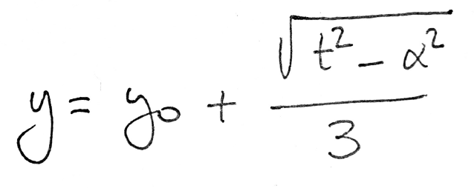

$$y= y_{0}\frac{\sqrt{{(t}^{2}}-α^{2})}{3}$$

1. **Sketches, images and the Snipping Tool**

Digital notebooks are convenient and green, but sometimes we just need a space to sketch things. To include a sketch or diagram in your digital notebook, we will use a drawing tablet and a simple drawing software.

Double-click on the ***Sketch Space*** file. It will open a customized window of Paint.net. Use the drawing tablet to sketch and/or write something.

Use 1) two colors, 2) two line widths (by changing the Brush width) and 3) use an arrow and a textbox to label something.

**Note about the Eraser**: the Eraser deletes everything, including the white background! The problem can be avoided by: a) using Undo button or b) using a white brush instead of the eraser.

****To transfer your sketch (or any image) to the notebook, you could always save a JPG or PDF file, and then insert it in the Word document. However, there is an easier and faster option: use the **Snipping Tool** (on the Taskbar at the bottom of the screen) to take snapshots of any portion of your screen.

Then, you can simply copy the snip and paste it into your notebook.

Remember that you readjust the image as needed:

* + - * + Resize by dragging the corners.
        + Use **Cropping tool** to remove empty spaces. Quick Access: 
        + Many other image-editing tools are available under Picture Tools (click on an image and the red Picture Tools option will appear on top of the screen).

Use the Snipping Tool to capture your sketch and insert it below.

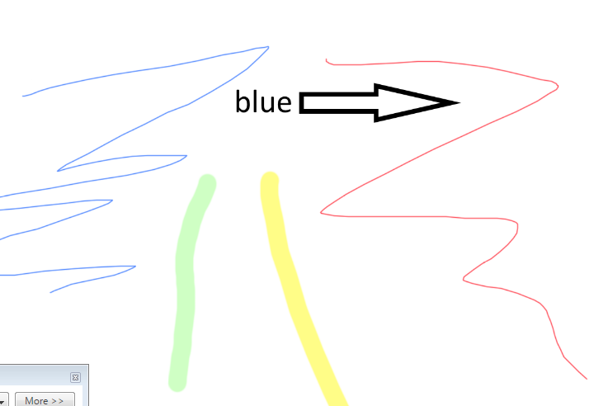

1. **Logger Pro**

Data will be collected from a variety of sources. The methods go from simple processes like reading a ruler, all the way to digital sensors connected to the computer.

* 1. **Collecting data through sensors**

**Whenever we use sensors** that send data directly to the computer, you should **always use the .cmbl file in the folder that corresponds to the experiment** to open Logger Pro, to ensure that you are working with the appropriate predefined settings.

Example: Find the *Labs Material* folder on your desktop. Inside, open your course folder, then the current experiment’sfolder, and finally open the file *Sample.cmbl*. This is just an example, so some data is already there.

What is the title of the graph? Enter it in the space below.

Dampened Harmonic Oscillations

* 1. **No sensors**

If you are just going to use Logger Pro to enter data manually, simply open the program directly from the desktop. You will define your own settings. A few of the available modifications are described next.

* 1. **Basic Logger Pro tools**

The following tasks will guide you through the most basic procedures in Logger Pro. The file *Logger Pro Help* (see “Helpful stuff” on Canvas) includes these and many other options and should be used as reference throughout the semester.

1. **Modify tables and enter data**
   * On the table, double click on the Time column. In the Column Definition tab, change the units to minutes.
   * Double click on the Displacement (*x*) column. This is a Calculated Column. It is generated from the formula in the Expression box. We will work on an example of a Calculated Column below. In the meantime, in the Options tab, change the Point symbol to a different shape and select a different color.
   * On the top toolbar, select Data and Add Manual Column, with the following parameters:

Name: Time 2

Short Nm: t2

Units: s

Once the column is created, add 5 random values between 0 and 10.

* + Select Data again, and Add Calculated Column, with the following parameters:

Name: Displacement 2

Short Nm: x2

Units: m

Expression: ,

which should be entered as 3*”Time 2”+2*”Time 2”^2

Note that “Time 2” can be either typed or selected from the drop menu of Variables (Columns). If you cut and paste from the notebook, you will get the wrong type of quotation marks and thus an error…

1. **Modify graphs**
   * + Right-click on the graph and select Graph Options. In the Graph Options tab, and:
       - Change the title of the graph to whatever you fancy.
       - Explore the “Connect Points” option. As you can see, the connecting lines can be misleading if the data is not “in order” (in this case, note in the table that *t* = 100 and *t* = 200 are in the “wrong” places.)
     + You can manually change the scale of the graph: click and drag the top end of the vertical axis until the plot is squeezed to the bottom third of the graph. In general, presenting a graph like this is a bad practice!
     + Then, click on Autoscale . Most of the time, this provides the optimal display.
     + Let us now graph the two columns we introduced, *x2 vs*. *t2.* On the top toolbar, select Insert and Graph. An *x2 vs*. *t* graph will appear. But this is the wrong time! Click on the label of the horizontal axis (“Time”) and select the desired quantity (“Time 2”)
2. **Auto Arrange**

On the top toolbar, select Page and Auto Arrange.

1. **Inserting Logger Pro tables and graphs onto the notebook**

The Snipping Tool is once again the easiest way.

Insert below a capture of the two graphs together. It should look nice if you have been following all the steps!

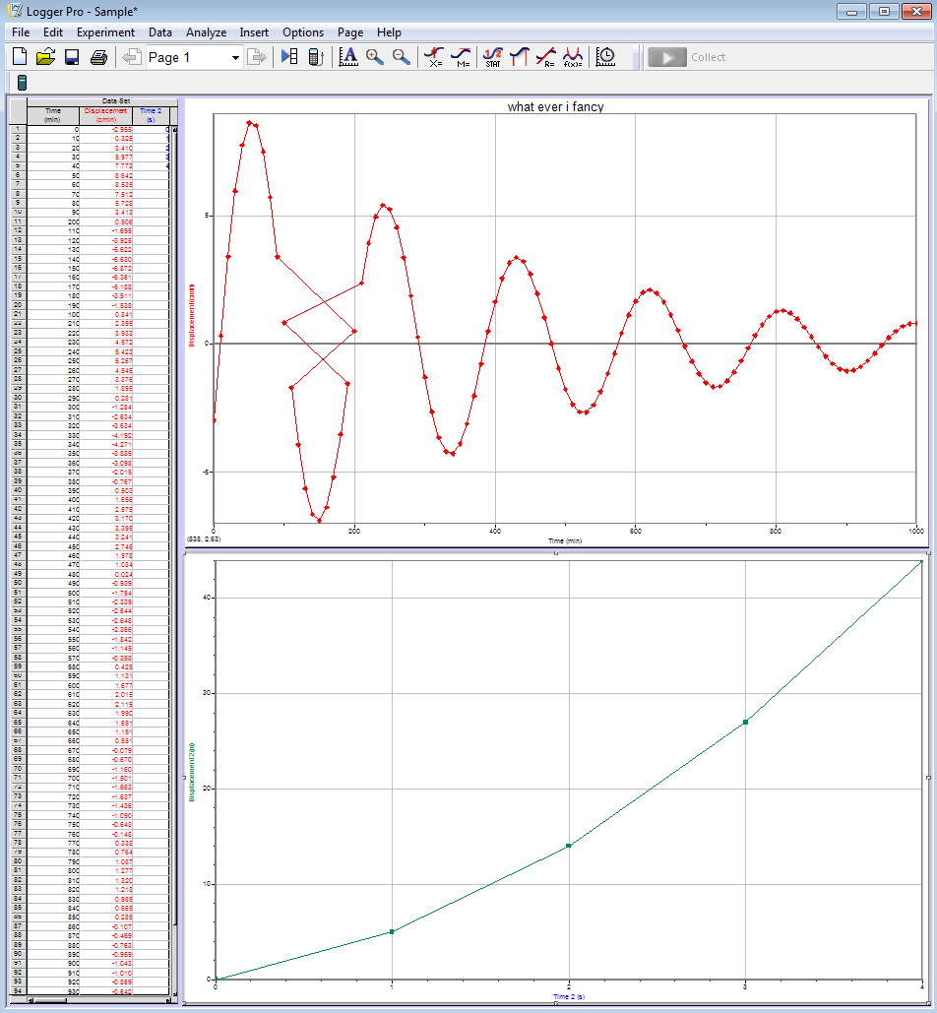

1. **Saving data**
   * + Save the whole document in the Logger Pro format (extension .cmbl). Logger Pro is available in all the help room computers.
     + You can also choose to save data as a .CSV, so you can open the data on Excel: File > Export As > CSV.
2. **Save and create PDF**

Save the notebook as a .docx. Then, produce a PDF of the entire notebook:

Quick Access: Or: File > Save as Adobe PDF

1. **Submit lab notebook and data**

At the end of each session and before leaving the lab, each student must submit the following documents on the corresponding lab on Canvas:

1. PDF of your notebook
2. Any data that is not in the notebook, as a .cmbl (Logger Pro) or .cvs (Excel) files.

**This is an individual process. It is NOT acceptable to do one submission per group.**

1. **What you should always keep and take home**

This is the material that you may need to write your lab report.

1. Lab notebook (word document)
2. Any file not included in the notebook
3. Any non-digital records

**Lab FES - Fundamentals of experimental science:**

**Introduction to measurement and statistics**

1. **Metrology**

In the prelab, you watched the podcast *Metrology*.

* 1. **Resolution, range, best estimate, error**

In experiment B in the Metrology slides, we used a mechanical balance with 0.1-g calibrated masses to measure the mass of a sample.

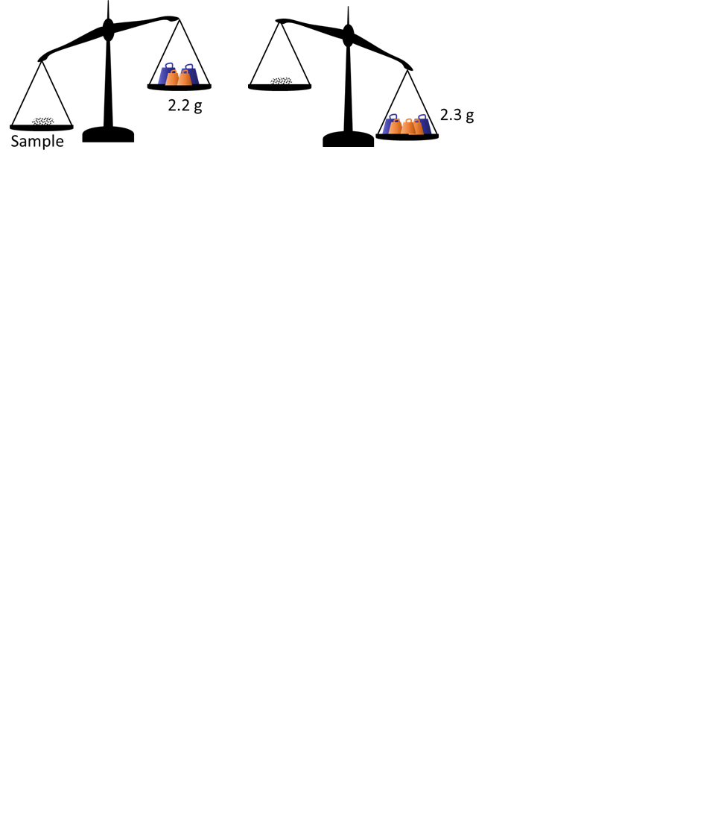

Assuming that the balance works properly and that the scale masses are very well calibrated, write below the result of this experiment with 100% probability:

* As a range
* As a best estimate ± error.
* As a best estimate ± percentage error.

(2.2,2.3)

2.25g $±$ 0.05g

2.25 $±$ 2.22%

As a rule of thumb, **the uncertainty can be taken as half of the resolution of the equipment**.

* 1. **Other scales**

**Digital scale**

We instead place our sample on a digital scale and obtain the reading shown to the right.

Would this scale allow you to differentiate between samples with masses 2.241 g and 2.2386 g? Explain.

Since the 2 samples are different after the third digit you could not differentiate between the 2 samples using the scale because the scale rounds the numbers.

How far below 2.24 g could the value be (with this reading on the display)?

2.235g

How far above 2.24 g could the value be?

2.2449999999… g

Using these two limits above and below, write the measurement as a range, and then as a best estimate ± uncertainty.

(2.235,2.244999999…)

2.24g $±$.005g

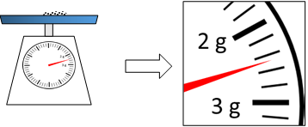**Dial scale**

The figure to the right shows what the reading would look like if we used a dial scale.

What is the smallest amount you can discern on the dial: 0.2 g? 0.1 g? Maybe even 0.05 g?

In this case, resolution depends on the ability of each experimenter! And that means that experimenters will also produce a slightly different uncertainty (which is half of the resolution, remember the rule of thumb defined at the end of section 1.1).

Let’s settle for a resolution of 0.1 g. Write the reading above as best estimate ± uncertainty.

2.5g $±$ 0.05g

As you can see, the determination of uncertainty can be a complicated issue –and it will get worse in a while once we start talking about probabilities. For the purpose of this class, we want you to be able to obtain **some** estimate of the uncertainty that you can reasonably justify. Our main goal is that you understand why uncertainty must always be part of the result.

1. **Statistics**

Watch the prerecorded lecture *Statistics.*

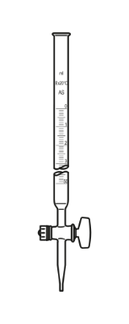**Add a spoonful of science**

A tablespoon is a common and convenient measurement used for cooking, and most households have measuring spoons in the kitchen. In the US, a tablespoon is supposed to be ½ fluid ounces, or 14.8 ml.

Last week, in the chemistry lab, you learned how to use a burette (the device shown to the right, which allows to deliver and measure a volume of liquid with high precision). So you take your set of measuring spoons to the lab, and, using the burette, fill with water the one labeled “1 Tbsp”. Aware of the importance of statistics, you repeat the measurement 10 times. The results are shown below:

|  |  |  |  |  |  |  |  |  |  |  |
| --- | --- | --- | --- | --- | --- | --- | --- | --- | --- | --- |
| Event | 1 | 2 | 3 | 4 | 5 | 6 | 7 | 8 | 9 | 10 |
| Volume (ml) | 14.89 | 14.65 | 14.71 | 14.59 | 14.92 | 14.70 | 14.46 | 14.55 | 14.54 | 14.60 |

Since it looks like the variations between measurements are much more important than the resolution of the pipette, we will neglect the error associated to the apparatus.

Enter this table on Logger Pro. Relabel X and Y to “Event” and “Volume”, and include the proper units. In the graph, select all the points and click on the Stat icon in the tool bar.

The software will then calculate the average and standard deviation of this data. You can use this to calculate the standard error. Enter your table, calculations and results below. (Remember to save the .cmbl file for your records.)

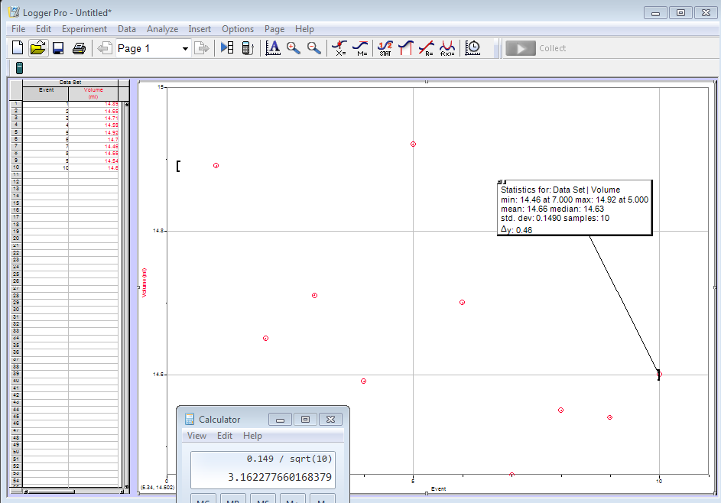

The standard deviation is a measurement of the variations within the sample. It should not depend much on whether we repeat the test 10, 20 or 100 times. However, notice that the standard error has a  in its denominator, where *n* is the number of measurements. In general, what happens to the standard error when *n* is very large?

As n gets larger the error get smaller because you have more data to decrease the chance for error.

This is one of the reasons why repetition is a crucial element of reliable measurements! Can you suggest another? (Hint: What is the result of the first measurement?)

We will have a more precise result

Does your 1-Tbsp measuring spoon meet the US standard? Explain.

Yes, with the standard deviation incorporated into the sample mean the threshold of 14.8ml is inside of this range.

1. **Significant figures**

Let’s imagine that we want to estimate the thickness of a sheet of paper.

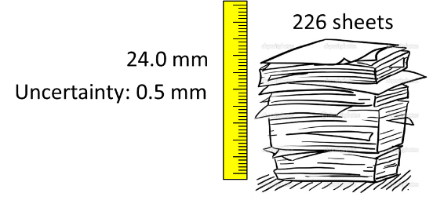So we take a pile of paper, we count the number of sheets, and obtain 226. Then, we measure how tall the pile is with a ruler: 24.0 mm.

As discussed in section 1, we could have a long argument about how much exactly should the uncertainty of this measurement be. Let’s settle to ± 0.5 mm

Then, the thickness of one sheet is… this?



Explain what is wrong with this result. Rewrite it with a **meaningful** number of significant figures, and explain your reasoning.

There are too many significant figures. It should be written as 0.106 $±$ 0.002.